|  |  |  |  |
| --- | --- | --- | --- |
| **Lyng Primary School Knowledge Organiser** | | | |
| **Geography** | **Great and Ghastly Events – Titanic and Moon landing**  **Where are the oceans and continents and what are they called?** | Year 1 | Spring |

|  |  |
| --- | --- |
| **What Step On and Goldilocks words will I use?** | |
| **Spelling** | **Definition** |
| continent | One of the earth's seven major areas of land. The continents are Africa, Antarctica, Asia, Australia, Europe, North America, and South America. |
| ocean | The vast body of salt water covering about three quarters of the earth's surface. |
| land | The solid part of the earth's surface. |
| ship | A large vessel built to carry people or goods long distances through deep water. |
| iceberg | A large floating mass of ice that has broken from a glacier. |
| glacier | A large mass of ice formed in cold regions from compacted snow and very slowly moving down a slope or across land. |
| country | A large area of land where people live under the same government or have the same culture. |
| Survivor | A person who survives. |
| voyage | A journey. |
| unsinkable | Unable to sink. |



RMS Titanic was a British passenger and mail carrying ocean liner, operated by the White Star Line. It sank in the North Atlantic Ocean on 15 April 1912 as a result of striking an iceberg. The journey was from Southampton, England, to New York City, United States.

Of the estimated 2,224 passengers and crew aboard, about 1,500 died, making it the deadliest sinking of a single ship up to that time. The disaster drew public attention, spurred major changes in maritime safety regulations, and inspired many artistic works.

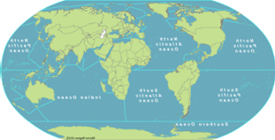

|  |
| --- |
| **Geographical study** |
| The continents are:   * Africa * Antarctica * Asia * Australia * Europe * North America * South America   There are five oceans:   * The Pacific Ocean * The Atlantic Ocean * The Indian Ocean * The Arctic Ocean * The Southern Ocean |

**Fieldwork Opportunities**

Make a ship in the hall, design a ticket and go on-board the ship.

**Significant places**

* Southamption
* New York

**Our Storytelling Approach to enhance engagement**

|  |  |  |
| --- | --- | --- |
| **People:**  **Eva Hart** | **Place:**  Titanic ship | **Problem:**  It has sunk. Will Eva Hart survive? |

**Key facts and locations**

**Map to be studied**

The Titanic was to travel from the UK, Southampton to USA, New York. However it tragically sunk in the Atlantic ocean after hitting an iceberg.

The 5 oceans of the world are:

**Pacific Ocean**: The largest and deepest ocean, covering about one-third of the Earth's surface.

**Atlantic Ocean**: The second largest ocean, separating the Americas from Europe and Africa.

**Indian Ocean**: The third largest ocean, located to the southeast of the Atlantic Ocean.

**Southern Ocean**: Also known as the Antarctic Ocean, it's the southernmost ocean surrounding Antarctica.

**Arctic Ocean**: The smallest and shallowest ocean, located around the North Pole and mostly covered by ice.

The continents in the world are:

**Asia:** The largest continent, known for its diverse cultures, landscapes, and histories.

**Africa**: The second largest continent, known for its deserts, savannas, and diverse cultures.

**North America**: The continent comprising Canada, the United States, Mexico, and several smaller countries. It's known for its vast landscapes, including forests, mountains, and plains.

**South America**: The continent located mostly in the southern hemisphere, known for its Amazon rainforest, Andes Mountains, and diverse ecosystems.

**Europe**: Where we live! A continent located in the eastern hemisphere, known for its history, cultural diversity, and landmarks.

**Australia**: A continent and country located in the southern hemisphere, known for its unique wildlife, vast deserts, and beautiful coastlines.

**Antarctica**: The southernmost continent, mostly covered in ice. It's known for its extreme cold temperatures and as the location of the South Pole.

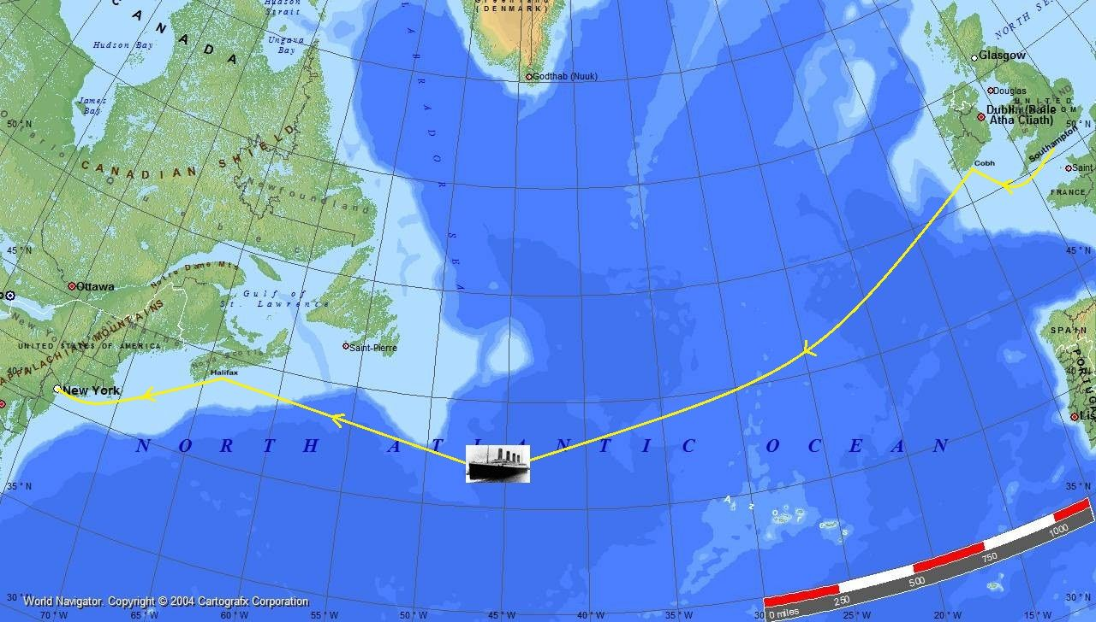

How many oceans are there?

What are the oceans called?

How many continents are there?

What are the continents called?

Which continent do we live in?

**Key questions**

**Agreed Outcome**

Write a newspaper article about the Titanic.

|  |  |  |  |
| --- | --- | --- | --- |
| **Lyng Primary School Knowledge Organiser** | | | |
| **Topic: Geography** | **Titanic and moon landing**  **Oceans and continents** | Year 1 | Spring |

|  |  |  |
| --- | --- | --- |
| 1. Which continent do we live in? | **S** | **E** |
| Asia |  |  |
| Europe |  |  |
| Africa |  |  |

|  |  |  |
| --- | --- | --- |
| 1. What continent is New York in? | **S** | **E** |
| Europe |  |  |
| North America |  |  |
| South America |  |  |

|  |  |  |
| --- | --- | --- |
| 1. Which continent is the coldest? | **S** | **E** |
| Africa |  |  |
| Antarctica |  |  |
| Australia |  |  |

|  |  |  |
| --- | --- | --- |
| 1. How many oceans are there? | **S** | **E** |
| 3 |  |  |
| 1 |  |  |
| 5 |  |  |

**Oceans and continents**

**Quick Quiz**

|  |  |  |
| --- | --- | --- |
| 1. Which ocean is the biggest? | **S** | **E** |
| Indian |  |  |
| Pacific |  |  |
| Atlantic |  |  |

|  |  |  |
| --- | --- | --- |
| 1. Where did the Titanic sink? | **S** | **E** |
| Southern ocean |  |  |
| Atlantic ocean |
| Arctic ocean |

|  |  |  |
| --- | --- | --- |
| 1. Where was the Titanic travelling to? | **S** | **E** |
| Southhampton |  |  |
| New York |  |  |
| West Bromwich |  |  |

|  |  |  |
| --- | --- | --- |
| 1. How many continents are there? | **S** | **E** |
| 7 |  |  |
| 8 |  |  |
| 9 |  |  |